Name: Agung Yuda Pratama Cohort ID:BDSE-0922-076

**Default Pages**

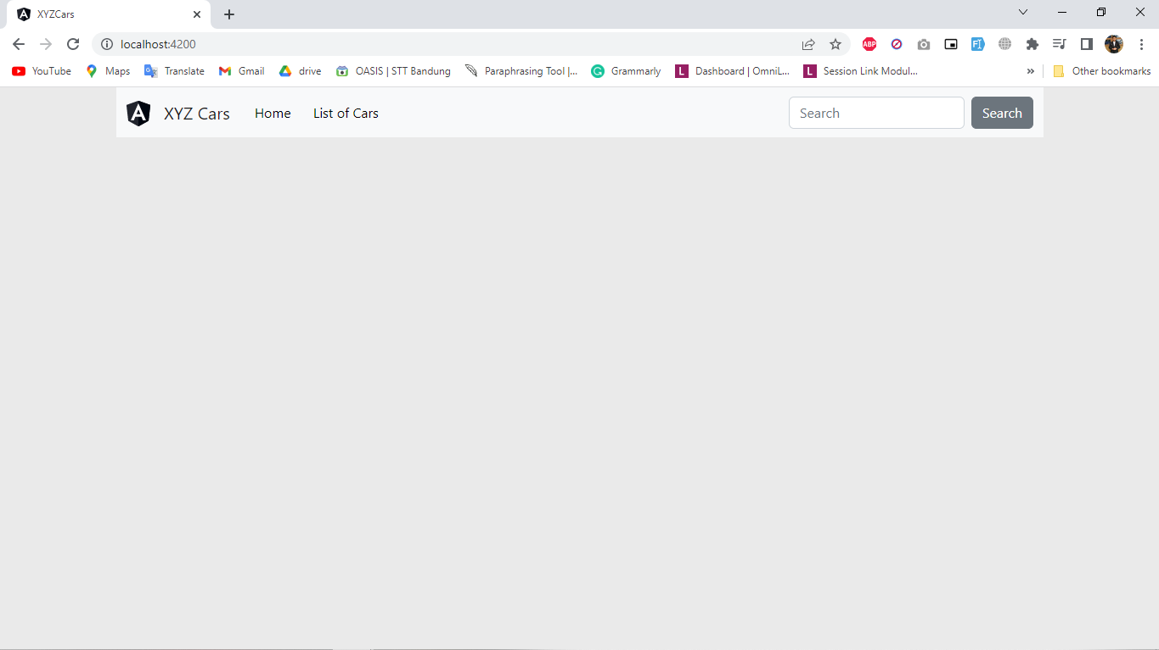

**Welcome Pages**

If you click the button Home in the Navbar, it will show Welcome.

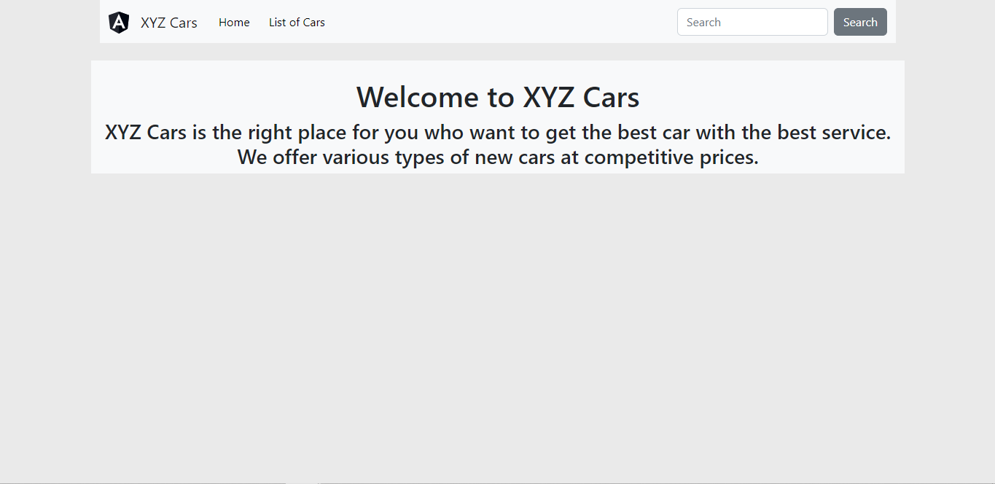

**List of Cars Pages**

If you click the button List of Cars, it will show different cars.

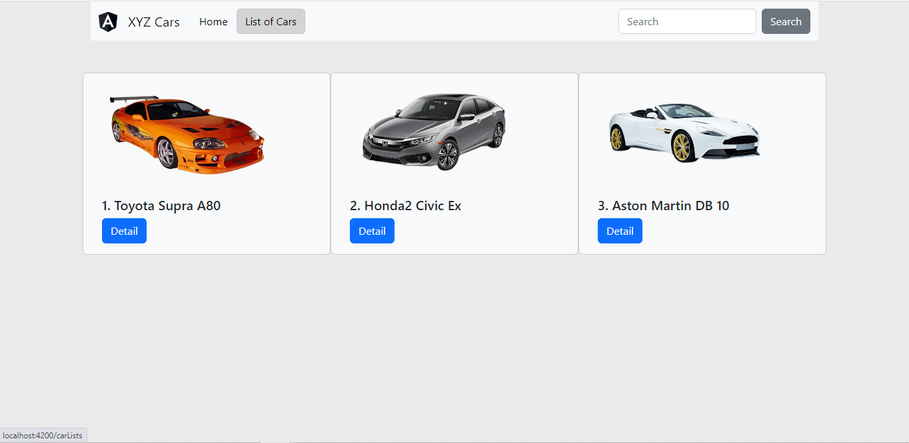

**Cars Details Page**

If you click on details, it will show the details of each of the cars. And if you click the Go Back button, it will go back to the List of Cars Page

